

Machine Learning Mini Project Report

Team Members : Mohamed Sheik M & David Ephraim S

Year/Sem : 2nd Year / 4th Sem

Department : Artificial Intelligence & Data Science

Subject Code : AL3461

Subject Name : Machine Learning Laboratory

Faculty Incharge : Mrs. Domi Evangeline S, Dept of AI&DS

Project Title : Criminal Detection Using ML

Faculty incharge

**Objective:**

Identify criminal faces in real time to ensure the safety of specific locations by issuing an alert.

**Algorithm Used;**

***Haar cascade classifier Algorithm***  is the algorithm used in our project

Haar cascade is an algorithm that can detect objects in images, irrespective of their scale in image and location.

Haar cascade works as a classifier. It classifies positive data points → that are part of our detected object and negative data points → that don’t contain our object.

* Haar cascades are fast and can work well in real-time.
* Haar cascade is not as accurate as modern object detection techniques are.
* Haar cascade has a downside. It predicts many false positives.
* Simple to implement, less computing power required.

**Code for Analysing Images:**

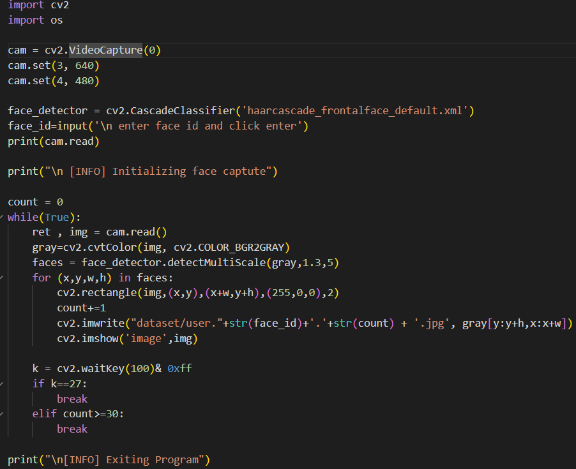

**It will Analyse the Pic of the Criminal and save it in a dataset**



**Output:** 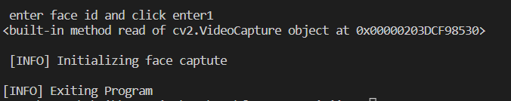

**Code for Train the Dataset:**

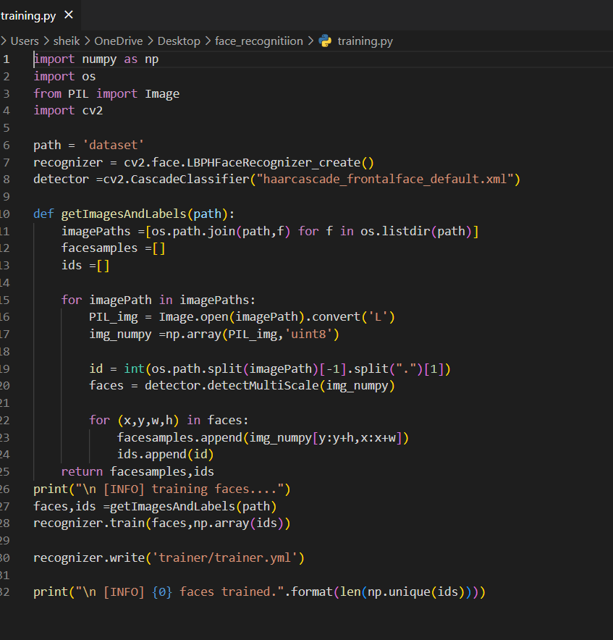

**It will train the No of faces in the Dataset**

**Output:**



**Code for Recognizing Criminal Faces in Real Time:** 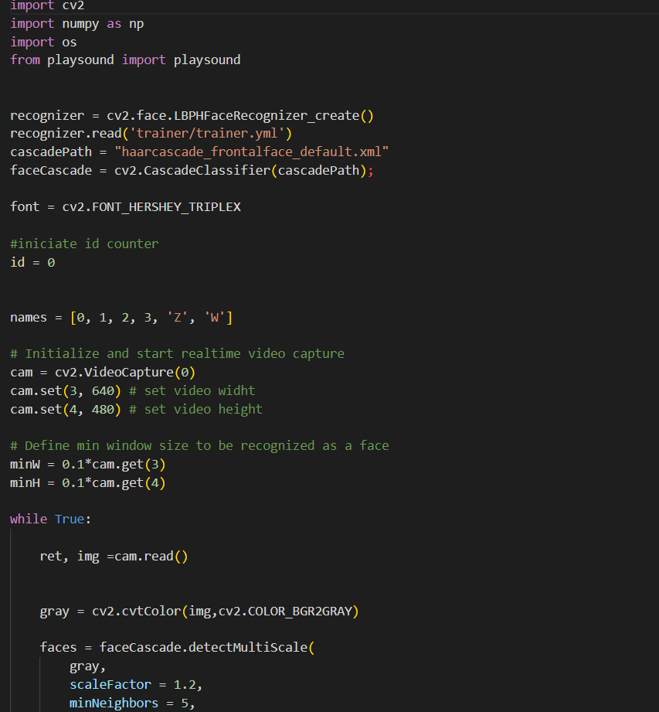

**Output 1:**



**It will detect the People in the Dataset**

**Output 2:**

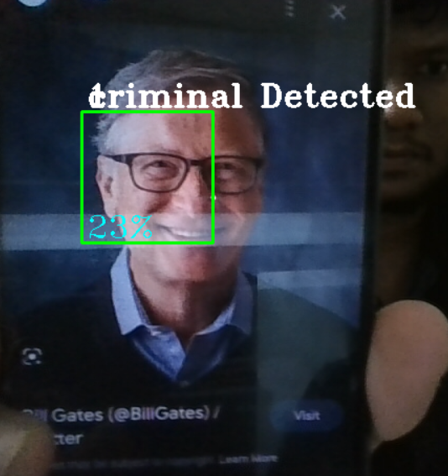



**Accuracy:**

We obtained an accuracy of 70% in our implementation

**Result:**

Thus, the Identification of criminal faces in real time using Haar cascade Classifier Algorithm was implemented successfully with an accuracy of 70%. and Detection of the criminal was Successfully notified with an Alert Sound.